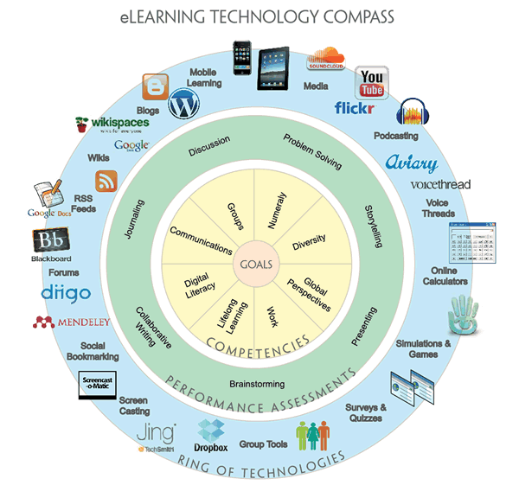  Using Technology with heart | KRISTA PODOLNY  EDU 315

Using Technology with Heart: A Plan for My Elementary Class

The 21st century teacher needs to be technologically literate. In the field of education, change is constant. Schools have come a long way from viewing technology “as distractions, devices like cell phones, mp3 players, and tablet computers are now being used as learning tools in forward-thinking schools” (Edutopia, 2007). The use of computers, tablets, mobile devices, child designed platforms (like, Amazon Kindle Fire for Kids, Nabi, and LeapFrog) and the internet by students has increased rapidly in recent years (U.S. Department of Education 2012). New York State’s Governor Andrew Cuomo pledged “a smart schools initiative [to] invest $2 billion in providing the technology of tomorrow today and to bring our classrooms up to speed in 2014” (NY State, 2014) in his 2014 State of the State Address. Technology is growing quickly in the lives of the child and the teacher.
As a NY State teacher, I intend to follow leaders in the field of education, like the National Association for the Education of Young Children (NAEYC), the Fred Rogers Center and the International Society for Technology in Education (ISTE) Standards for Teachers by facilitating, modeling, inspiring, designing, developing, engaging, growing, promoting, and showing leadership in the changing world of technology. When technology and interactive media are “used intentionally and appropriately… [they] are effective tools to support learning and development” (NAEYC, 2012). The Fred Rogers Center has a similar mission statement about technology, “when used intentionally by early childhood educators, within the framework of developmentally appropriate practice” (Rogers, 2015) it can support goals set for individual children. Therefore, when thinking about technology in the classroom, I always have two things in mind: to be intentional and developmentally appropriate.
If we look at technology in this light, it can be a useful tool for teachers and students and when integrated into the curriculum, technology has the possibility to revolutionize the learning process. Teachers who “recognize computers as problem-solving tools change the way they teach move from a behavioral approach to a more constructivist approach.” (Edutopia, 2007) Teachers can act as facilitators to engage, support and challenge the child’s learning.
A major challenge for teachers can be staying current in the fast passed changing world of technology. Teachers need the training and support required to develop technological knowledge, skills and experience. As educators we need to be able to effectively use technology and digital media in the classroom. Without this experience and practice, expensive devices, smart boards and interactive media can often be untouched, underused or wasted. The Fred Rogers Center offers “affordable, accessible, high-quality training to early childhood educators, regardless of their level of technological expertise” (Rogers, 2015). Educators are challenged to enrich their professional skills and be leaders in the field of education. The ISTE Standard 5 for teachers is: Engage in Professional Growth and Development. The standard asks teachers to “continuously improve their professional practice, model lifelong learning, and exhibit leadership in their school and professional community by promoting and demonstrating the effective use of digital tools and resources.” (ISTE, 2008) It is not enough for teachers to be knowledgeable about technology, but also be intentional about integration in the classroom. Intentional teachers can explain why they are doing what they are doing. By lesson planning and using standards, Common Core Learning Standards or ISTE Standards for Students, teachers can set goals with a plan for accomplishing it.
Instead of fighting against change, teachers must embrace technology with curiosity and excitement. Students and local governments are pushing for more technology and teachers need to be there to offer guidance. This guidance is incomplete without teacher’s vast knowledge in technology and integration. Teachers should use technology intentionally, using the standards and make sure that lessons are developmentally appropriate. As educators we can lead the way with support from training to develop technological knowledge, skills and experience.

References
-Edutopia (2007) “Why Do We Need Technology Integration? The myriad benefits of integrating technology into the classroom.” November 5, 2007
http://www.edutopia.org/technology-integration-guide-importance [accessed on 11/4/15]

-Edutopia (2007) “What Is Successful Technology Integration? : Well-integrated use of technology resources by thoroughly trained teachers makes twenty-first-century learning possible.” November 5, 2007 http://www.edutopia.org/technology-integration-guide-description [accessed on 11/4/15]
- International Society for Technology in Education (ISTE), (2008) “Standards For Teachers” http://www.iste.org/standards/iste-standards/standards-for-teachers [accessed on 11/4/15]
-NAEYC (2012) “Technology and Interactive Media as Tools in Early Childhood Programs Serving Children from Birth through Age 8” http://www.naeyc.org/content/technology-and-young-children [accessed on 11/4/15]

-Fred Rogers Center Fred for Early Learning & Children's Media (2015) http://www.fredrogerscenter.org/initiatives/digital-media-learning/about-digital-media-learning/ [accessed on 11/9/15]

-U.S. Department of Education 2012 “Rates of Computer and Internet Use by Children in Nursery School and Students in Kindergarten Through Twelfth Grade: 2012” https://nces.ed.gov/pubs2005/2005111rev.pdf [accessed on 11/4/15]

-NY State (2014) “Transcript: Governor Cuomo's 2014 State of the State Address” Jan 9 2014 https://www.governor.ny.gov/news/transcript-governor-cuomos-2014-state-state-address [accessed on 11/4/15]

