Science Inquiry Lesson Plan
Name__Krista Podolny________________________Date_____4/21/16_______________________
Science Concept(s) focused on: Grade: ___5th grade_____Length: ___________
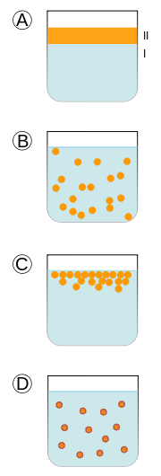
Chemistry of Cookies
- Content description/background:
Students will read, listen and watch various medias about the chemistry of cookies. They will taste cookies and fill out a
Rubric. Students will answer the essential question: what makes a cookie good? The students will present findings
based on learned knowledge and research.
Students will have a background/prior knowledge in the meaning of evaporation, chemical reaction (is a process that leads to
the transformation of one set of chemical substances to another), amino acids (are organic compounds containing
amine and carboxylic acid, important for the protein in our cookies).
- Key vocabulary (academic/everyday):
Emulsion: is a mixture of two or more liquids that are normally immiscible (unmixable or unblendable). Pictured here:
Salmonella: a bacteria that can cause illness, such as food poisoning.
Protein: are large biomolecules, or macromolecules, consisting of one or more long chains of amino acid residues
Heat energy: heat is energy as it spontaneously passes between a system and its surroundings, other than through
work or the transfer of matter
Millard reaction: is a chemical reaction between amino acids and reducing sugars that gives browned food its
desirable flavor.
Caramelization: is the browning of sugar, a process used extensively in cooking for the resulting nutty flavor
and brown color.
- Content of Previous Lesson:
- Content of Next Lesson:

- State the lesson rationale and essential questions guiding the learning experience: (Why are the outcomes of this lesson important in the real world? Why are these outcomes essential for future learning? How do the outcomes support 21st century skills?)
What makes a cookie good? How do you define good? How can you judge good?
In the research phase, students will critically analyze the research. Analyzing media sources and thinking critically are skills that students can apply in the real world, future learning and in other content areas. I have many checkpoints in this lesson to check for understanding and fill in any gaps along the way.

My students have an engaged interest in cooking and cookies. I wanted to build on that interest and add some tier 3 words to their vocabulary that many chefs and chemists use, like caramelization. Students can build on these interests with more content knowledge.

Learning Targets [OBJECTIVES]: What will the students know and be able to do as a result of this lesson? | Assessment (evaluate): How will you & your students know if they have successfully met the targets? What specific criteria will be met in a successful product/process? What does success on this lesson’s outcome look like? | Learning Standard Addressed:
a. SWBAT use scientific inquiry to pose questions and seek out answers.  b. SWBAT access and generate research, and develop a plan based on scientific method.  c. SWBAT analyze research and data and develop solutions. | a. Science of cookies Worksheet, if students can answer questions in worksheet it will demonstrate their understanding of the lesson at this point. There is a discussion period, where the teacher can fill in any gaps of understanding before moving forward.  b. Rubric Worksheet, students will drive deeper into the essential questions and analyze the products, starting to develop a plan for research.  c. Presentation of the research, plan, product, data, solutions and refection. | a. Standard 1: Students will use mathematical analysis, scientific inquiry, and engineering design, as appropriate, to pose questions, seek answers, and develop solutions.  c. Standard 2: Students will access, generate, process, and transfer information using appropriate technologies  b. Standard 1: Students will use mathematical analysis, scientific inquiry, and engineering design, as appropriate, to pose questions, seek answers, and develop solutions.
Student-Friendly Translations  a. ask and answer questions  b.research and plan  c.research turns into data | a. Science of Cookies Wooksheet  b.Rubric for tasting  c. Group Presentation | a. ask and answer questions, get solutions  b. ask and answer questions, starting research  c. research and present

Access for All: How will you ensure all students have access to and are able to engage appropriately in this lesson? Consider all aspects of student diversity (ie. English as a Second Language). | Assessment Access for All: How will you ensure all students have access to and are able to be assessed appropriately in this lesson? | Learning Standard Addressed::
a. Multiple means of expression: reading, video and audio.  b. The video explains tier 3 words.  c. Visuals in video help ELL students make meaning. | a. Giving students extra time  b. Lots of mini assessments throughout the lesson to check for understanding.  c. Group presentations: students can help each other and deepen learning. | a.SL.5.5.a  Report on a topic or text or present an opinion, sequencing  ideas logically and using appropriate facts and relevant,  descriptive details to support main ideas or themes; speak  clearly at an understandable pace.  b. SL.5.5.b  Include multimedia components (e.g., graphics, sound) and  visual displays in presentations when appropriate to enhance  the development of main ideas or themes.

Lesson Process:
Engage:
Read: The Chocolate Chip Cookie School Book
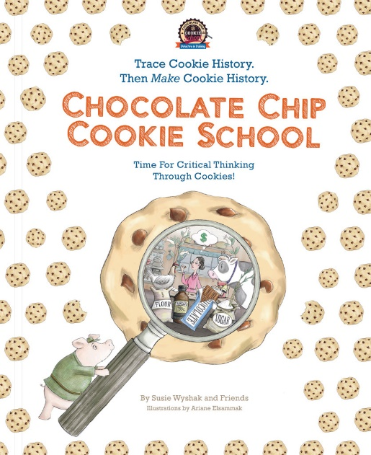
-Watch Ted Ed Video about the science of cookies http://ed.ted.com/lessons/the-chemistry-of-cookies-stephanie-warren#watch
After the video, test for knowledge (formal assessment worksheet) and discuss the worksheet/video as a group (informal assessment)
The Science Of Cookies

What’s the first change that occurs in your cookie dough after you put the pan in the oven?
Water boils
Butter melts
Proteins unfold
Caramelization occurs

Where do most of the proteins in cookie dough come from?
Sugar
Eggs
Butter
Flour

At what temperature does caramelization begin?
356°
400°
310°
256°

What is the leavening agent sodium bicarbonate another name for?
Carbon dioxide
Baking soda
Water
Hydrogen

What makes cookies light and airy?
Steam evaporating
Carbon dioxide gas created by the leavening agent
Butter melting
Both A and B

Can you think of other dishes you cook that involve the Maillard reaction? What about caramelization?

How would adding or removing ingredients change your final cookie?

At what temperature would you take the pan out of the oven to create your ideal cookie? What would that cookie look and taste like? (Draw a picture and explain)
Explain and Elaborate: To get students to ask questions and create wonder, we are going to have a COOKIE TASTING!
With 4 different types of cookies, suggested cookies (small) chips ahoy, famous amos, homemade soft and homemade crunchy, use the worksheet (attached) to rate each cookie and answer questions.
Taster:_______________________________________
Rubric / Scoring Sheet
Cookie #______________
Softness:
4 | 3 | 2 | 1
gooey and chewy | Soft and moist | Tough | Hard and crunchy

Taste:
4 | 3 | 2 | 1
Sweet and chocolatey | I can taste chocolate, a little sweet | Not sweet | Salty
Delicious and scrumptious | Good | Okay-but could be better | Yucky and gross

Size:
4 | 3 | 2 | 1
Greater than 3.5 in | 2.5-3.25 in | 1-2 in | Less than 1 in

Notes: (Please describe look, taste, feel…)
______________________________________________________________________________________________________________________________________________________________________________________________________________________________________________________________________________________________________________________________________________________________________________

Which Cookie was the best out of the four you tasted?
Give reasons why you thought that one was the best:
Why do you think some cookies tasted better than others?
If you were the baker, what changes would you make to the cookies?
How do you think we could make the rubric better?
Elaborate:
-Lets do some more research:
*http://www.npr.org/templates/story/story.php?storyId=92421142
Listen to min 2:08 to 3:10
Transcript:
RAZ: Shirley, how do you - what does 36 hours in the refrigerator actually do? How does that make cookie dough better?
Ms. CORRIHER: OK. Well, number one, cookie doughs are very low moisture, and the only moisture in the doughs is usually the little bit of water that is in the butter, and the egg, if the recipe has an egg, and chocolate chip cookies do have eggs. So, standing that long lets that moisture permeate through the batter, the dough, and spreads the flavors here. It just lets the whole mass, sort of, amalgamate, flavor-wise. The flavors are totally different.
If you make a big batch of cookie dough, and let it, you know, bake some instantly, and save those as number one, and then bake some after 12 hours, bake some more after 24 hours, and bake some more after 36 hours, you will find a number of differences. They get slightly darker in color, and they get more uniform. So, if you're using an ice cream scoop, or whatever, they're going to be the perfect same size. But the most wonderful thing is the flavor. Oh, taste testers go crazy over those 36-hour cookies.
RAZ: How do you leave - how do you leave cookie dough in the fridge for 36 hours without wanting to consume it? What about salt? There's a lot of salt now being used in sweet things.
Ms. CORRIHER: Yes. Salt has - now, you don't think of salt as saltiness. This is so little salt you don't taste salty, but salt has an amazing ability to suppress bitterness. The people at Monell Chemical Senses Center do a demo, and they will give you a little sample of tonic water, you know, grocery store quinine water, and you take a sip and you can taste the bitter quinine and then the sugar water that's in there to make it palatable. And then they put a little bit of salt in the rest of the bottle, and give you another sip, and it's almost like sugar water.
Salt has this fascinating ability to suppress off flavors, and let the other flavors come through. So, salt is a potent thing in desserts. You'll always hear pastry chefs say, don't forget the salt. It brings out the sweetness, and this is exactly what it does. It suppresses the bitterness so the sweetness and the other flavors in the dough can come through loud and clear.
-Questions:
Based on your research, independently (if time) or research above, what are some ways we can change the standard cookie recipe? What would you change? What prediction could you make? How do you think it would change the cookie? Where is your research from? Who wrote it? What is the intention of the author? Why is this important for your research?
Look at recipes and explain why they would or wouldn’t be good…
Evaluate: Group Presentation (3 students) of your findings and research. Answer questions: What are you looking for? How are you defining good? What other items would you include in the rubric? How would you design a cookie experiment?
Group Presentations need to have:
-Multimedia Component
-Speak clearly… ever group member talks
-Expresses an opinion
-Uses facts and represents research
-Expresses ideas and facts in a logical way/sequence
Closing: Reflect on the lesson and process.
Class discussion: Is it hard/easy to all come up with the same standards for good? What were some things we came up with? Do we see some themes? What are some differences? What is taste? Why do we have differences in taste?
If time activity: Look up pictures of famous French desserts, what do they have in common? How are they different than desserts you have had before? What is a typically dessert in your family/culture? *Has anyone ever heard that France is famous for their desserts? Pastries? Croissants?
Extended activity:
  - The Maillard reaction is named after the French scientist Louis Camille Maillard (1878-1936), who studied the reactions of amino acids and carbohydrates in 1912, as part of his PhD thesis, which was published in 1913. The Maillard reaction is not a single reaction, but a complex series of reactions between amino acids and reducing sugars, usually at increased temperatures. Like caramelization, it is a form of non-enzymatic browning. In the process, hundreds of different flavor compounds are created. These compounds in turn break down to form yet more new flavor compounds, and so on. Each type of food has a very distinctive set of flavor compounds that are formed during the Maillard reaction.
Lesson Modifications
Student’s Initials | Modification/Accommodations: What curriculum modifications and/or classroom accommodations will you make for Students with Disabilities in your class? Be as specific as possible: | Expected Student Outcomes associated with Lesson Modification/Accommodations:
1. AA  2. MK  3. | 1. Individual iPad for video and audio, headphones, transcript of audio and extra time for student with autism.  2. Passing microphone during discussion and necklace microphone for student with hearing aid.  3. | 1.n/a-same as other students  2.n/a- same as other students  3.

Resources/References:
http://ed.ted.com/lessons/the-chemistry-of-cookies-stephanie-warren#digdeeper
http://www.npr.org/templates/story/story.php?storyId=92421142
Salmon, S. (2009) “Chocolate Chip Cookies and Rubrics: Helping Students Understand Rubrics in Inclusive Settings” Teaching Exceptional Children, Vol. 35, No. 4, pp. 8-11. https://homepages.gac.edu/~dmoos/documents/rubric_004.pdf
Materials:
-Chocolate Chip Cookie School Book
-4 boxes of chocolate chip cookies (or enough for each student to have one from each box)
-Milk (optional)
-Worksheet #1
-Worksheet #2
-Access to computers or iPads for research, if independent research is offered
- Ted Ed video
-NPR Audio

