There have also been many legends and stories that have been told about the Sand Dollar. Some legends say that they were just “pressed sand.” Others say that they were mermaid money, a currency used deep under the sea by the mer-people. Some people believe that finding a whole Sand Dollar is good luck. Others believe they’re gifts from God, or a sign from Heaven with five doves keep inside.
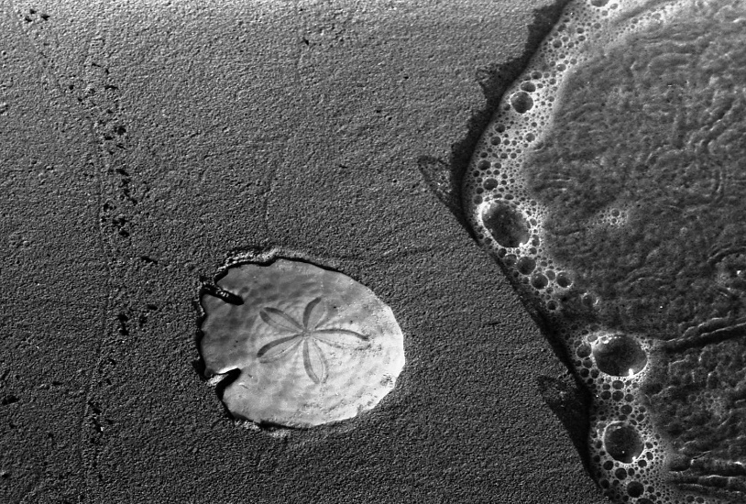
98% of the creatures on Earth are invertebrates. Clams, crabs, and coral are invertebrates, as well as arachnids, butterflies, mollusks, protozoa, starfish, and sand-dollars. Invertebrates, like amphibians, tend to be cold-blooded and rely on their surroundings to help them regulate their body temperatures. Most invertebrates live in water or moist atmospheres, though some insects inhabit dry land and have developed water-proofed shells. Invertebrates vary just as much as vertebrates do—just think of all the differences between a squid and a spider!

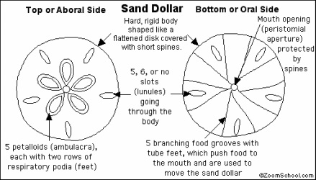

What does a sand dollar look like if it breaks?
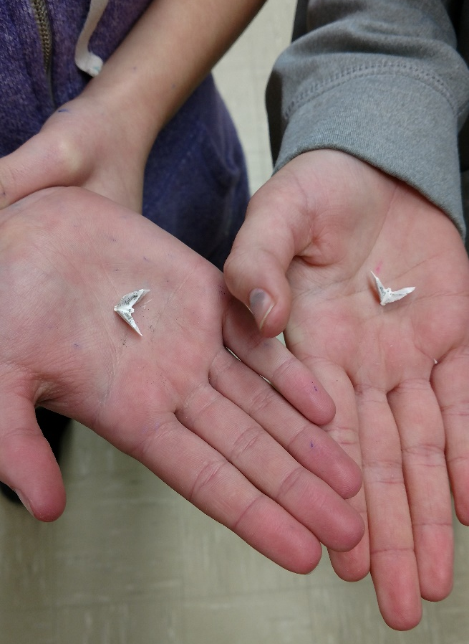
Sand dollars are relatives of sea urchins and sea stars. This group of animals is grouped together based on their spiny skin (they are called echinoderms; echino=spiny; derm=skinned) and a symmetry based on five. The five "doves" referred to in the story are actually remnants of the sand dollar's five "teeth". When alive, sand dollars are covered in short black spines as well as tube feet. To feed, the sand dollars trap food in mucus between these short spines. The food is transported to the mouth (on the underside) by tracts of cilia. They also feed on food trapped between, or covering, sand grains. The mouth is the large hole on the underside, while the anus is the other hole at the edge of the underside of the test. The small holes on the "top" of the sand dollar are where eggs are released.
Do we see a difference in the two sand dollars?
Florida Sand Dollar Characteristics: Mexico Sand Dollar Characteristics:

