Krista Podolny
EDU 340
Green Day Event
4/26/16

Rosamond Gifford Zoo

I volunteered my in son’s kindergarten class field trip on Friday, April 23, 2016, at the Rosamond Gifford Zoo in Syracuse, NY. The teacher had 6 parent volunteers, each volunteer had 2-3 children in there group. The teacher handed out iPads to each volunteer with an assignment. The assignment was a scavenger hunt worksheet, we had to take pictures of certain animals that fit each section. For example, an animal that swims, endangered animal, etc. Children took turns using the iPads to take pictures of the animal and writing the animals name in the section on the worksheet. It was hard work… we needed a lunch. We ate lunch outside by the Asian Elephant Preserve. The area is being reinvented, so we got to watch tractors make a large pool for the elephants, pretty entertaining! 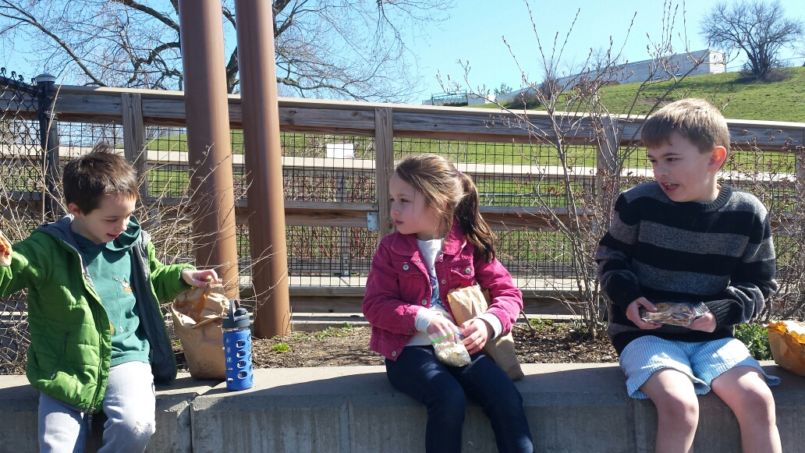
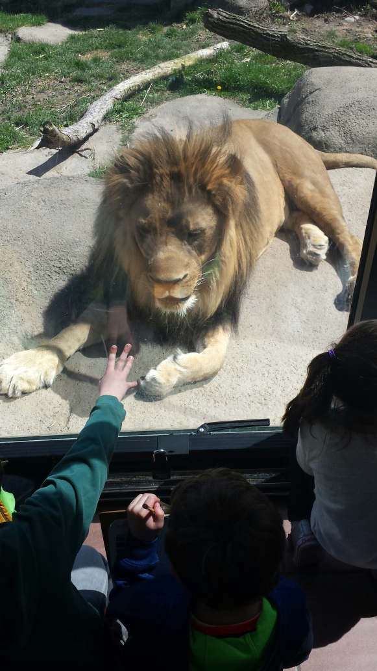
This zoo is a great place to have a field trip because 60 percent of the exhibits are indoors (and it Syracuse, with our crazy weather, that is pretty important), like the diversity of birds aviary, the U.S.S Antiquities area (submarine themed area) that holds an aquarium, lots of fish, a giant pacific octopus, sea stars, anemones, reptiles, invertebrates, amphibians and plants. There is another area indoors that holds all the nocturnal animals, like sloths (the kids were making lots of references to the new children’s movie Zootopia), foxes, bats, and mole rats. This area is fun because it is dark and the kids were quiet. Then off to the lion corridor, where there are African Lions. The lions were very impressive and pushed up against the glass. We got a up-close look.
Some of the outdoor exhibits include the Penguin Coast (Love!), wildlife trails (small, but fun), domestic animal barn (we pet a donkey and I almost stepped on a chicken), Russian tigers (люблю), outdoor birds, monkeys (somewhere inside and somewhere outside), deer and wolves.
The kids had a blast! Then off to the bus to go back to school, with a filled out worksheet and 50 pictures on an ipad. It was cool to see a field trip run by a master teacher (she has taught kindergarten for 20 years) and it was a great day with my crazy 5 year old. I really liked that the teacher gave the students a job during the field trip, instead of just walking around the zoo, looking at animals, she created an activity that really deepened their learning, they walked away knowing what endangered meant and had a picture of the animal. They took pictures of different habitats. I am definitely going to borrow that idea.

